Verify Check  Cab  Cleanliness  Seat condition OK  Operator restraint provided  Instruments operational & labeled  Levers / controls operational  Pedals in good condition  ROPS to AS 2294  Windows / wipers / washers  Rear view mirrors  Operator instruction  (available on plant)  Log book  SWL / crane chart  Warning devices  Verify Check  Horn  Amber flashing beacon  Reversing alarm  Verify Check  Warning signs (in cabin)  SEAT BELTS MUST BE WORN  Verify Check  DANGER – BEWARE OVERHEAD WIRES,  PIPES and SERVICES | Supplier verification & Plant details
 | Plant owner:
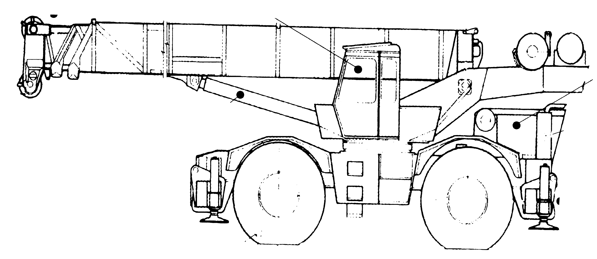 | Address:
Verify Check  Pivots  Connecting rods  Safety pins  (no excessive wear)  Boom | City/Suburb:
 | Phone:
 | Plant make:
 | Plant model:
 | Serial no.:
Verify Check  Engine guarding | Signature:
Verify Check  Hambone & wedge | Date:
Verify Check  Exhaust | Work Cover Certification – C2 or C6
Hydraulics  Verify Check  Rams  Hoses  Connections  (check for excessive  wear, leaks and creep)  Verify Check  Tyres  Wheels  Brakes  Park brake  Verify Check  Slew radius / barricading  for around outriggers |  Plant to conform to manufacturer’s specifications and Plant Regulations.   Plant operator is to provide daily checksheets to WDA on a weekly basis   Where applicable, Personal Protective Equipment must be worn.   Plant Log Book detailing service history in accordance with Manufacturer’s specifications should be written legibly in English.   Contractor must produce proof of competence of operator, e.g., Certificate of Competence, Licence, detailed Log Book
Verify Check  Handrails  Steps | WDA use only
Verify Check  Slings / ropes / chains (tagged and in good working order)  Electrical wiring (no visual signs of damage)  Steel or timber pads  Verify Check  Outriggers & rams  operational | Note: Sign only when all items have been checked
 | Plant check by:
Instructions:  Verify Box to be ticked by Owner / Supplier / Operator prior to arrival onsite.  Check Box to be ticked after visual inspection by WDA | Position:
 | Date: |  | / /

